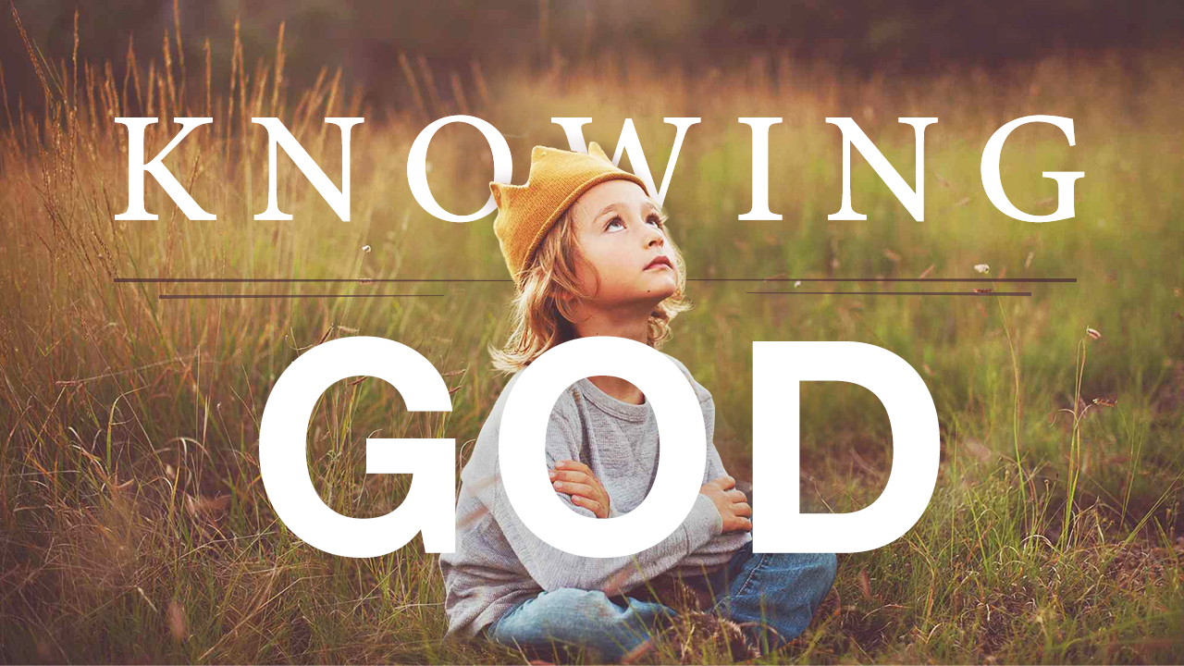
Worship Evening – Knowing God

Please note that this worship evening can either be used as is or as a template. Feel free to change and adjust it as needed based on your congregation’s resources and song knowledge.

Sing “How Great Thou Art” (H 15)

Prayer and welcome

Read Matthew 18:2-4. Why does Jesus say this? What is it about children that Jesus loves? (allow time for responses and sharing)

Children are humble, teachable and curious. Are we humble, teachable and curious? Do we humbly allow God the Holy Spirit to teach us? Are we curious to know more about Him (Father, Son, Spirit)?

Jesus once asked His disciples a very pointed question: “Who do people say the Son of Man is?” The disciples replied, “Some say John the Baptist; others say Elijah; and still others, Jeremiah or one of the prophets.” Without pause, Jesus asks perhaps one of the most powerful questions in all of scripture: Who do you say I am?”

Now, this question is for us. Who do we say that Christ is? Who do we say that God the Father is? Who do we say that God the Holy Spirit is?

Let’s increase our awareness of the Triune God, starting with the Father. Who do you say that God the Father is? (allow time for responses and sharing)

Tonight we’re going to focus on God the Father as Creator.

God, the Father - Creator

Because God is the Creator, He Himself was not created. He is the uncreated Creator. Even though He is the author and the finisher, the beginning and the end—He has no beginning nor end. He always was, always is, and always will be.

Worship is part awareness and part expression. Now that we’ve become more aware of God’s attributes, let’s express this awareness together with singing.

We’ll sing the first and second verses of “God, the Uncreated One.” Since this will be a new song for some, please join in as you feel comfortable doing so.

Sing “God, the Uncreated One” (verses 1 and 2)

God the Father is the source of all things. Everything that we can see around us was created by Him. As the hymn states, “All good gifts around us are sent from Heaven above.”

Read Colossians 1:16-17

Let’s thank God now for His provision by singing all verses of “For the Gifts of Heaven.” The soloist will sing the first verse, and then everyone can sing verses 2 and 3.

Sing “For the Gifts of Heaven” (all verses)

God, the Son – Savior

Who do you say that God the Son is? (allow time for responses and sharing)

Let’s spend some time focusing on the glorious truth that Christ is our Savior.

If it weren’t for Christ, we would be forced to suffer for our sins—not only in this life, but also for all eternity. When we take even just a moment to imagine this, we quickly realize why the good news of the gospel is so good. Christ took our sins upon Himself on the cross. Because of Him, we don’t have to suffer under the consequences of our sin, in this life or the next. Because of him, we have the opportunity for eternal life and fellowship with the Triune God. He has rescued us from our sin. What a wonderful Savior we have!

Let’s sing of Him now. We’ll sing all verses of the familiar hymn, “A Wonderful Savior Is Jesus” (H 363)

Sing “A Wonderful Savior Is Jesus” (all verses)

We can’t save ourselves from our sin; only Christ can save the sinner. He is the way, the truth, and the life. No one can come to the Father except through Him.

Read Romans 5:1-2

Through Christ we have peace with God. Through Him we have access by faith into the grace of God. In Christ alone, our hope is found.

Please join in singing all three verses of “In Christ Alone” (H 92)

Sing “In Christ Alone” (all three verses)

God, the Holy Spirit – Breath of God

Who do you say that God the Holy Spirit is? (allow time for responses and sharing)

The song that we’re about to sing describes the Holy Spirit as the breath of God. What does this mean, that the Holy Spirit is the breath of God? The Hebrew word behind spirit is ruach, which means "air in motion." It is the same word for "breath,” and also means "life." We can read early on in Genesis where God breathed on Adam and gave him the breath of life. We can also read in the 20th chapter of John of an account where Jesus breathed on His disciples.

Read John 20:21-22

These two verses clearly show us that the Holy Spirit is the breath of God. Through Him, we are made spiritually alive; He is the life and the spirit of God within us. Through Him, the things of the Father and of the Son are revealed to us. Through Him, we become a new creation.

Let’s sing to Him now, asking Him to revive our hearts, renew our minds, and refresh our souls. The soloist will sing the first verse of “O Breath of God,” and then we can sing verses 2-4 together.

Sing “O Breath of God” (all verses)

How incredible it is that we can grow in the knowledge of our Savior, the Risen Christ; that we can grow in the knowledge of the Almighty God, creator of Heaven and Earth; and that we can grow in the knowledge of the Holy Spirit, the living Breath of God.

It seems only fitting that we end our worship this evening by praising this blessed Trinity. Please stand and join in singing all three verses of “Holy, Holy, Holy” (H 14)

Sing “Holy, Holy, Holy” (all verses)

